ANA NEWS

ANA Unveils Star Wars™ R2-D2 Livery for 787-9 Dreamliner Aircraft
The First and Only Passenger Aircraft to Feature a Star Wars Character

Anaheim, CALIFORNIA, April 16, 2015 – All Nippon Airways (ANA) announced today it will introduce Star Wars livery, with the iconic R2-D2, on its newest aircraft 787-9 Dreamliner to mark the beginning of a five-year ANA Star Wars™ Project and agreement with The Walt Disney Company (Japan) Ltd.* This marks the first time a Star Wars character will appear on the exterior of a commercial aircraft. The R2-D2 design was unveiled to Star Wars fans today at Star Wars Celebration in Anaheim, California, just months prior to the character’s appearance on international flights** in autumn of this year.

The Star Wars livery is in line with ANA’s strategy to further enhance its international presence. Last spring, the carrier significantly expanded its international flight network from Haneda and Narita airports in Tokyo. With demand increasing around the world for flights to Japan and routes linking the United States with Asia, ANA is committed to raising the profile of the ANA brand in the global market through innovative partnerships and branding opportunities. The partnership with Star Wars, beloved by audiences in Japan and around the globe, is a perfect match as Japan’s largest airline seeks to connect travelers around the world through this project.

"We’re excited to be involved in this collaboration with ANA, one of the world's leading 5-star airlines,” said Kayleen Walters, Vice President, Marketing for Lucasfilm Ltd. “We’re proud of the innovative R2-D2 design, and we look forward to witnessing the first-ever flight of a passenger aircraft featuring a Star Wars character. We’re confident that Star Wars fans around the world will absolutely love this design."

"ANA boasts an extensive international network, along with convenient connections between the U.S. and a wide variety of destinations throughout Asia,” said Takashi Shiki, ANA Executive Vice President, Sales & Marketing. “Although it’s a lofty goal, we hope that like Star Wars, ANA will become well known and loved across all borders and generations. The R2-D2 motif works well with ANA’s blue logo design on the aircraft’s fuselage, and many people associate R2-D2 with competent and reliable service—also hallmarks of ANA’s 5-star service. We are particularly delighted to introduce this collaboration now as we prepare to launch our new international service from Tokyo to Houston in June, making it our 10th North American destination. Through the introduction of the new Star Wars livery we hope to welcome more passengers from around the world to experience ANA as the Inspiration of Japan."

ANA also launched its special website featuring the Star Wars collaboration. For more information on the ANA Star Wars Project, please visit: http://www.ana-sw.com

* ANA Star Wars Project is a five-year agreement with The Walt Disney Company (Japan) Ltd. in Japan and spanning from 2015 to 2020
** Routes and flights operated by the aircraft with Star Wars livery have not been determined

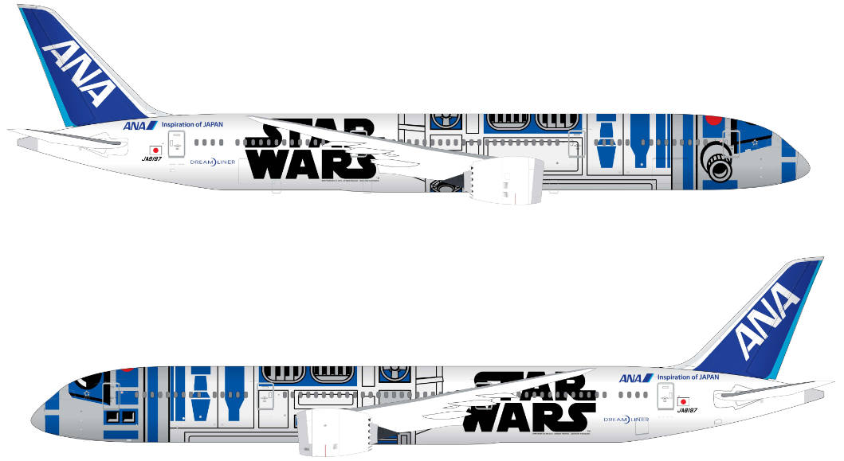

Follow the ANA Star Wars Project on our social media channels:
https://www.facebook.com/flyworld.ANA
www.twitter.com/flyANA_official #SWCA

For more information on ANA, visit: www.fly-ana.com
For more information on Star Wars, visit: http://www.starwars.com/

STAR WARS and related properties are trademarks and/or copyrights, in the United States and other countries, of Lucasfilm Ltd. and/or its affiliates. © & TM Lucasfilm Ltd.

Contact : Ryosei Nomura and Maho Ito, ANA Public Relations 81-3-6735-1111

About ANA
All Nippon Airways (ANA) is the 13th largest airline in the world by revenues (2013) and the largest airline in Japan by revenues and passenger numbers. Founded in 1952, ANA flies today on 72 international routes and 113 domestic routes with a fleet of about 240 aircraft. ANA Group has 33,000 employees. In 2013, it carried 46 million passengers and generated revenues of 1.6 trillion Japanese yen. ANA has been a member of Star Alliance since 1999 and has joint-ventures with United Airlines on trans-Pacific and Asia routes and with Lufthansa, Swiss International Airlines and Austrian Airlines on Japan-Europe routes. Its Frequent Flyer Program, ANA Mileage Club, has more than 26 million members. ANA was voted Airline of the Year for 2013 by Air Transport World Magazine, and in 2015 was awarded five stars for the third consecutive year by the world's leading Airline and Airport review site, SKYTRAX. ANA is the launch customer and biggest operator of the Boeing 787 Dreamliner.

###

